Visual proteomics using whole-lamella 2D template matching

This manuscript ([permalink](https://jojoelfe.github.io/deco_lace_template_matching_manuscript/v/51095028c49de7986e39cc0ee234d0f6cdbddee1/)) was automatically generated from [jojoelfe/deco_lace_template_matching_manuscript@5109502](https://github.com/jojoelfe/deco_lace_template_matching_manuscript/tree/51095028c49de7986e39cc0ee234d0f6cdbddee1) on March 21, 2022.

## Authors

* **Johannes Elferich** ORCID icon [0000-0002-9911-706X](https://orcid.org/0000-0002-9911-706X) · GitHub icon [jojoelfe](https://github.com/jojoelfe) RNA Therapeutic Institute, UMass Chan Medical School; HHMI
* **Nikolaus Grigorieff** ORCID icon [0000-0002-1506-909X](https://orcid.org/0000-0002-1506-909X) · GitHub icon [nikogrigorieff](https://github.com/nikogrigorieff) RNA Therapeutic Institute, UMass Chan Medical School; HHMI

## Abstract

Localization of biomolecules inside a cell is an important goal of biological imaging. Fluorescence microscopy can localize biomolecules inside whole cells and tissues, but its ability to count biomolecules and accuracy of the spatial coordinates is limited by the wavelength of visible light. Cryo-electron microscopy (cryo-EM) provides highly accurate position and orientation information of biomolecules but is often confined to small fields of view inside a cell, limiting biological context. In this study we use a new data-acquisition scheme called “Defocus-Corrected Large-Area cryo-EM” (DeCo-LACE) to collect high-resolution cryo-EM data over entire sections (100 – 200 nm thick lamellae) of neutrophil-like mouse cells, representing roughly 1% of the total cellular volume. We use 2D template matching (2DTM) to determine localization and orientation of the large ribosomal subunit in these sections, detect bound small ribosomal subunits and assign ribosomes to polysomes based on their relative orientations to each other. These data provide “maps” of translational activity across sections of mammalian cells. This new high-throughput cryo-EM data collection approach together with 2DTM will advance visual proteomics and complement other single-cell “omics” techniques, such as flow-cytometry and single-cell sequencing.

## Introduction

A major goal in understanding cellular processes is the knowledge of the amounts, location, interactions, and conformations of biomolecules inside the cell. This knowledge can be obtained by approaches broadly divided into label- and label-free techniques. In label-dependent techniques a probe is physically attached to a molecule of interest that is able to detected with a high signal-to-noise signal, such as a fluorescent molecule. In label-free techniques the physical properties of molecules themselves are used for detection. An example for this is proteomics using mass-spectrometry [1]. The advantage of label-free techniques is that they can provide information over thousands of molecules, while label-techniques offer highly specific information for a few molecules. Especially spatial information can often only be achieved using label-dependent techniques, such as fluorescence microscopy [2].

Cryo-electron microscopy has the potential to directly visualize the arrangement of atoms that compose biomolecules inside of cells, thereby allowing label-free detection with high spatial accuracy. This has been called “visual proteomics” [3]. Since cryo-EM requires thin samples (<500nm), imaging of biomolecules inside cells is restricted to small organisms, thin regions of cells, or samples that have been suitably thinned. Thinning can be achieved either by mechanical sectioning [4] or by milling using a focused ion beam (FIB) [5]. his complex workflow leads to a low throughput of cryo-EM imaging of cells and is further limited by the fact that at the required magnifications, typical fields of view (FOV) are very small compared to mammalian cells, and the FOV achieved by label-techniques such as fluorescence light microscopy. The predominant cryo-EM technique for the localization of biomolecules of defined size and shape inside cells is cryo-electron tomography [6]. However, the requirement of a tilt series at every imaged location and subsequent image alignment, severely limits the throughput for molecular localization.

An alternative approach is to identify molecules by their structural “fingerprint” in single projection using “2D template-matching” (2DTM) [7,8,9]. In this method a 3D model of a biomolecule is used as a template to find 2D projections that match the molecules visible in the electron micrographs. This method requires a projection search on a fine angular grid, and the projections are used to find local cross-correlation peaks with the micrograph. Since the location of a biomolecule in the z-direction causes predictable aberrations to the projection image, this method can be used to calculate complete 3D coordinates and orientations of a biomolecule in a cellular sample [8]

Hematopoiesis is the process of generating the various cell types of the blood in the bone marrow. Disregulation of the process results in diseases like leukemia. Understanding how hematopoietic stem and progenitor cells are programmed to diffferentiate to the appropriate cell type would be provide new insight how hematopoiesis can be misregulated. Of special interest is the regulation of translation during hematopoiesis. This is exemplified by the observation that genetic defects in the ribosome machinery often leads to hematopoietic disease[10]. As such direct quantification of ribosome location, number and conformational states could lead to new insight into hematopoietic disease [11].

Here we apply 2D-template matching of ribosomes to cryo-FIB milled neutrophil-like murine cells [12]. To increase the amount of collected data and to provide unbiased sampling of the whole lamella, we devised a new data-acquisition scheme, Defocus-corrected large area cryo-electron microscopy (DeCo-LACE). We characterize aberration cause by the used large beam-image shifts and highly focused beams and find that they can be adequately corrected to enable ribosome detection by 2DTM. The resulting data provide a description of ribosome distribution in the whole lamellae, which represent roughly 2% of the cellular volume. We find highly heterogeneous density of ribosome within the cell and can identify discrete clusters of presumably translationally active ribosomes, by testing for the presence of the small ribosomal subunit. The high accuracy of location and orientation of each detected ribosome also allows us to cluster ribosome molecules into potential polysomes. Analysis of the throughput in this method suggests that for the foreseeable future computation will be the bottleneck for visual proteomics.

## Materials and Methods

### Grid preparation

ER-HoxA9 cells were maintained in RPMI supplemented with 10% FBS, penicillin/streptomycin, SCF, and estrogen [12] at 37C and 5% CO2. 120h prior to grid freezing cells were washed twice in PBS and cultured in the same medium, except without estrogen. Differentiation was verified by staining with Hoechst-dye and insepction of nuclear morphology. Cells were then counted and diluted to 1^106 cells/ml. Grids ( either 200 mesh copper grids, with a sillicone-oxide and 2um holes with a 2um spacing or 200 mesh gold grids with a thin gold film and 2 um holes in 2um sapcing) were glow-discharged from both sides using a … for … . 3.5 ul of cells suspension was added to grids on the thin-film side and grids were automatically blotted from the back-side using a GP2 cryoplunger (Leica) for … s and rapidly plunged into liquid ethane at -185C.

### FIB-milling

Grids were loaded into a Acquilos 2 FIB/SEM microscope with a stage cooled to -190C. Grids were sputter-coated with platinum for 15s at 45 mA and then coated with a layer of platinum-precursor by openin the GIS-valve for 45s. An overview of the grid was created by montaging SEM images and isolated cells at the center of gridsquares were selected for FB-milling. Lamella were generated automatically using the AutoTEM software, resulting in 6-8 um wide lamella with 150-200 um thickness as determined by FIB-imaging of the lamella edge.

### Data collection

Grids were loaded into a Krios Titam TEM operated at 300 keV. The microscope was setup with a cross-grating grid on the stageby setting the beam-diameter to 900 nm, resulting in the beam being completely visible in the camera. To establish fringe-free conditions, the “Fine eucentric” procedure of serialEM was used to move a square of the cross-grating grid to the eucentric position of the microscope. The effective defocus was then set to 2 um, using the “autofocus” routine of serialEM. The objective focus of the microscope was changed until no fringes were visible. The stage was then moved in Z until images had a apparent defocus of 2 um. The differnce in stage Z-position between the eucentric and fringe-free conditions was calculate d and noted to move other areas into fringe-free condition.

Low magnification montages were used to find lamella and lamella that were sufficiently thin and free of contamination were selected for automated data collection. The corners of the lamella were manually annotated in SerialEM and translated into Beam-Imageshift values using SerialEm calibration. A hexagonal patter of beam-imageshift positions was calculated that covered the area between he four corners in a serpentine way, with a sqrt(3) * 400 nm horizontal spacing and 800 nm vertical spacing. Exposures were then taking at each position with a 30 e/A total dose. After each exposure that defocus was estimated using the ctffind function of SerialEM and the focus for th next exposure was corrected by the difference between the estimated focus and the desired defocus of 800 um. Also after each exposure the deviation of the beam from the center of the camera was measured and corrected using the “CenterBeamFrom IMage” command of SerialEM.

After datacollection a 20s exposure at 2250x magnification of the lamella at 200um defocus was taken for visualization purposes.

### Data pre-processing

Movies were gain-corrected and motion-corrected using a custom version of unblur. To avoid influence of the beam-edge on motion-correction only a quarter of the movie in the center of the camera was considered for calculation of the estimated motion. After movie frames were aligned and summed a mask for the illuminated area was calculated by lowpass filtering the image at … A, thresholding the image at 10% of the maximal value and then lowpass filtering the mask at … A. This mask was then used to replace un-illuminated area with gaussian noise, with the same mean and standard deviation as the illuminated area. The contrast-transfer function (CTF) was estimated using ctffind, searching between 0.02 and 2 um defocus.

### Template matching

The search template was generated from the cryo-EM structure of the mouse large ribosomal subunit (PDB 6SWA). The … subunit was deleted from the model and the simulate program of the cisTEM suite was used to calculate an density map from the atomic coordinates. The match_template program was used to search for this template in the preprocessed images, using 1.5 deg angular step in out-of-plane angles and 1.0 deg in-plane. 21 defocus planes in 200nm steps centered around the defocus estimates by ctffind were searches. Matches were defined as peaks above a threshold calulated according to .. .(7.75 for most images).

### Data analysis

## Results

### 2D-Template matching can be used to find ribosomal subunits in cryo-FIB thinned lamella of mammalian cells

To test whether we could detect individual ribosomes in mammalian cells we prepared cryo-lamella of mouse neutrophil-like cells. Low-magnification images of these lamellas clearly shows cellular features consistent with a neutrophil-like phenotype, mainly a segmented nucleus and a plethora of membrane-organelles, corresponding to the granules and secretory vesicles of neutrophils. We then proceeded to acquire micrographs on this lamella with a defocus of 0.5-1.0 um, 30 e/A2/s exposure and 1.5 A pixelsize. We manually selected multiple locations in the lamella and focused using standard low-dose techniques, i.e. by first ensuring correct focus by imaging a sacrifical area. The resoluting micrographs showed no signs of crystalline ice and had thon-rings to resolution, indicating successfull vitrification.

We used an atomic model of the 60S mouse ribosomal subunit (6SWA) for 2D template matching. In a subset of images the distribution of cross-correlation scores significantly exceeded the distribution expected from non-signifcant matching(Figure 1B). In the resulting scaled maximum-intensity maps, clear peaks with SNR thresholds up to 10 were apparent (Figure 1C). By using the criterion described by for thresholding potential matches we found that in images of cytosolic ompartments we found evidence of 10-500 ribosomes in the imaged areas. Notably we found no matches in images that were taken in the nuclear compartment. In the cytosolic areas we found a drastically different number of matches, In somer areas we found only ~ 50 matches er image area, corresponding to a concentration of…, while in another area we found more than 500 matches, corresponding to a concentration of … .

### cryo-EMILIA for 2D imaging of whole lamella

In order to obtain high-resolution data for complete lamella we used a new approach for data collection. This approach uses three key strategies: (1) ensures that every electron that exposes the sample is collected on the camera (2) uses beam-image shift to precisely and quickly raster the surface of the lamella and (3) uses a focusing strategy that does not rely on a sacrificial area.

To ensure that every electron exposing the sample was captured by the detector, we focused the electron beam so that the entire beam was placed on the detector. During canonical low-dose imaging the microscope is configured so that the focal plan is identical to the eucentric plane of the specimen stage. This leaves the C2 aperture out of focus, resulting in ripples at the edge of the beam (Figure 2B). While these ripples are low-resolution features that might not interfere with 2D template matching, which is designed to be robust to low-resolution noise, we also tested collecting data under a condition where the C2 aperture is in focus (Figure 2C).

We then centered a lamella under the electron beam and used beam-image shift of the microscope to systematically raster the whole surface of the lamella in a hexagonal pattern. Instead of focusing in a sacrificial area, we determined the defocus after every exposure using a routine implemented in SerialEM modeled after CTFFind. The focus was then adjusted based on the difference between desired and measured defocus. Since we used a serpentine pattern for data collection every exposure is close to the previous exposure making drastic changes in the defocus unlikely. Furthermore we started our acquisition pattern on the platinum deposition edge, so the initial exposure where the defocus was not yet adjusted did not contain any biologically relevant information.

We used this strategy to collect data on 8 lamella, 4 using the eucentric focus condition and 4 using the fringe-free condition. We were able to highly consistently collect data with a defocus of 8 um (Figure 2D), both in the eucentric focus and fringe-free focus condition. Together with the nominal defocus of the microscope this data results in a topological map of the lamella. To ensure that data was collected consistently, we mapped defocus values as a function of the applied Beam-image shift (Figure 2E). This demonstrated that the defocus was consistent over the lamella, with outliers only at isolated images and in images containing contamination. We also plotted the measure objective astigmatism of the lamella and found that it varies with the applied Beam-image shift, become more astigmatic mostly due to beam-image shift in the X direction. While approaches exist to correct this during the data-collection, we opted to not use these mechanism for these early experiments and instead rely on computational correction of these aberrations in order to characterize them.

### 2D-Template matching of cryo-EMILIA data reveals ribosome distribution

We developed customized preprocessing protocol to images obtained by cryo-EMILIA to enable their use for 2D-template matching. First we restricted calculation of cross-correlation coefficients between individual movie frames to the central portion of the image to prevent artifacts from the beam edges on estimation of motion. Then we calculated a mask that defined the illuminated area of the micrographs and used it to fill non-illumated areas with gaussian noise, matching mean and standard deviation to the illuminated signal (Figure 3A). The so processed images were suitable for 2D-template matching and we were able to obtained matches with the same model used for the data in Figure 1.

### Quantitative analysis of translation activity

## Discussion

* Elizabeth Wright and Grant Jensen Montage tomography papers
* Waffle method for higher throughput, automation of fib-milling
* Throughput and bottlenecks
* Visual proteomics
* Granules containing ribosomes?
* Threshold implications (no matches on most images)

## Figures

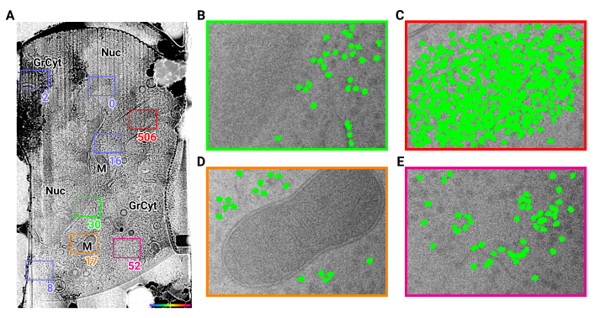

Figure 1: 2D template matching of the large subunit of the ribosome in fib-milled neutrophil-like cells (A) Overview image of the lamella. Major cellular regions are labeled, as Nucleus (Nuc), Mitochondria (M), and granular cytoplasm (GrCyt). FOVs where high-magnification images for template matching where acquired are indicated as boxes with the number of matches indicated on the bottom right. FOVs displayed in Panels B-E are color-coded. (B-E) FOVs with projection of ribosome LSU matches shown in green. (B) Perinuclear region, the only matches are in the cytoplasmic half. (C) Cytoplasmic region with high density of ribosomes (D) Mitochondrium, as expected there are only matches in the cytoplasmic region (E) Cytoplasm, with low density of ribosomes.

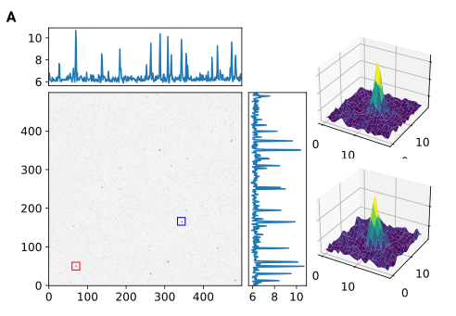

Figure S1: Maximum intensity projection cross-correlation map of micrograph shown in Figure 1

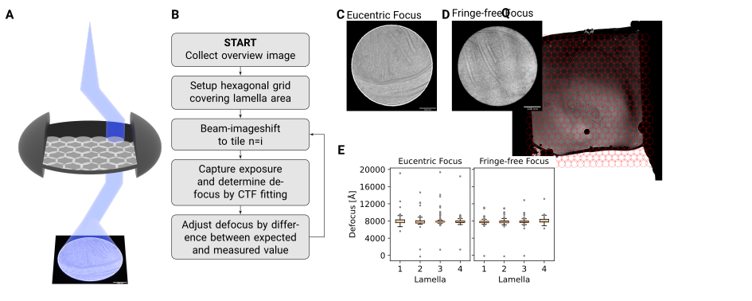

Figure 2: DeCo-LACE approach (A) Graphic demonstrating the data-collection strategy for DeCo-LACE

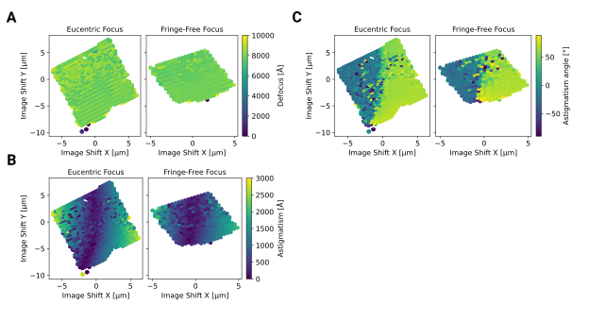

Figure 3: This is an example-figurern

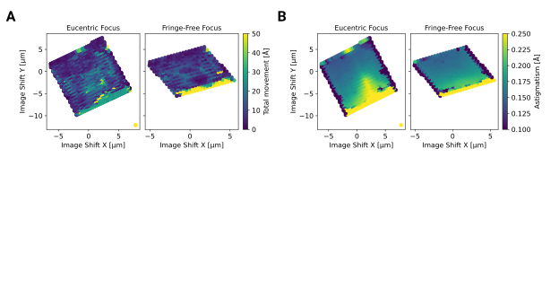

Figure 4: This is an example-figurern

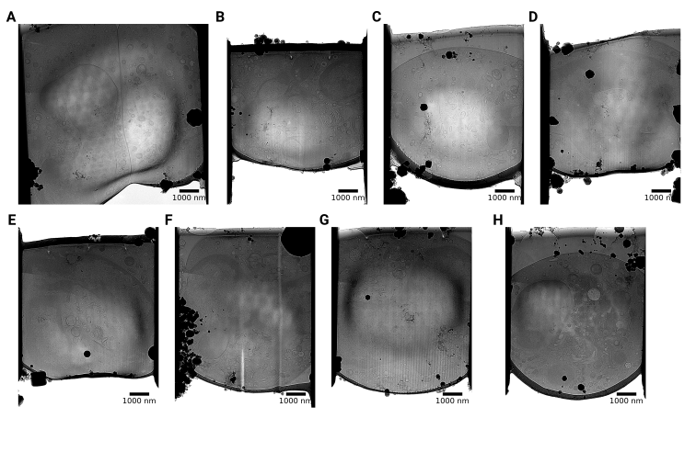

Figure 5: This is an example-figurern

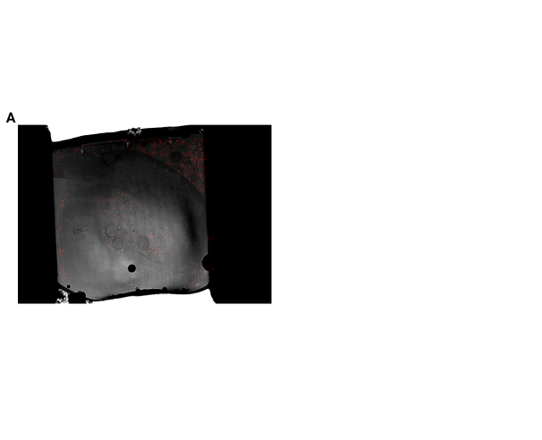

Figure 6: This is an example-figurern

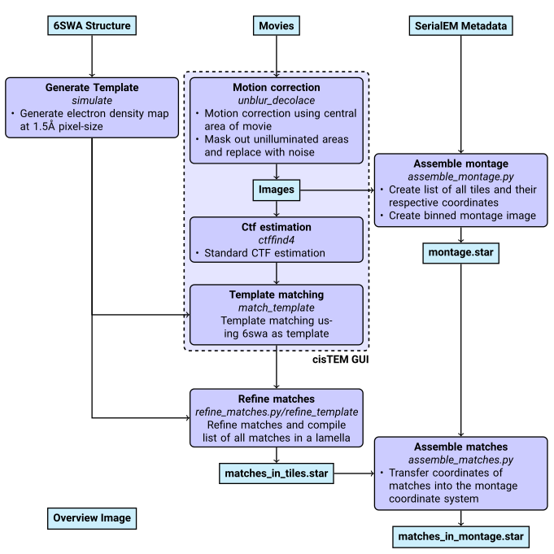

Figure 7: Workflow of DeCo-Lace processing

## References

1. **Label-free, normalized quantification of complex mass spectrometry data for proteomic analysis** Noelle M Griffin, Jingyi Yu, Fred Long, Phil Oh, Sabrina Shore, Yan Li, Jim A Koziol, Jan E Schnitzer *Nature Biotechnology* (2010-01) <https://doi.org/fshgnc> DOI: [10.1038/nbt.1592](https://doi.org/10.1038/nbt.1592) · PMID: [20010810](https://www.ncbi.nlm.nih.gov/pubmed/20010810) · PMCID: [PMC2805705](https://www.ncbi.nlm.nih.gov/pmc/articles/PMC2805705)

2. **Fluorescence microscopy** Jeff W Lichtman, José-Angel Conchello *Nature Methods* (2005-11-18) <https://doi.org/bbpg4n> DOI: [10.1038/nmeth817](https://doi.org/10.1038/nmeth817) · PMID: [16299476](https://www.ncbi.nlm.nih.gov/pubmed/16299476)

3. **A visual approach to proteomics** Stephan Nickell, Christine Kofler, Andrew P Leis, Wolfgang Baumeister *Nature Reviews Molecular Cell Biology* (2006-02-15) <https://doi.org/d6d5mq> DOI: [10.1038/nrm1861](https://doi.org/10.1038/nrm1861) · PMID: [16482091](https://www.ncbi.nlm.nih.gov/pubmed/16482091)

4. **Electron microscopy of frozen hydrated sections of vitreous ice and vitrified biological samples** AW McDowall, J-J Chang, R Freeman, J Lepault, CA Walter, J Dubochet *Journal of Microscopy* (1983-07) <https://doi.org/bdnzmv> DOI: [10.1111/j.1365-2818.1983.tb04225.x](https://doi.org/10.1111/j.1365-2818.1983.tb04225.x) · PMID: [6350598](https://www.ncbi.nlm.nih.gov/pubmed/6350598)

5. **Opening windows into the cell: focused-ion-beam milling for cryo-electron tomography** Elizabeth Villa, Miroslava Schaffer, Jürgen M Plitzko, Wolfgang Baumeister *Current Opinion in Structural Biology* (2013-10) <https://doi.org/f537jp> DOI: [10.1016/j.sbi.2013.08.006](https://doi.org/10.1016/j.sbi.2013.08.006) · PMID: [24090931](https://www.ncbi.nlm.nih.gov/pubmed/24090931)

6. **Electron tomography of cells** Lu Gan, Grant J Jensen *Quarterly Reviews of Biophysics* (2011-11-15) <https://doi.org/czj9hr> DOI: [10.1017/s0033583511000102](https://doi.org/10.1017/s0033583511000102) · PMID: [22082691](https://www.ncbi.nlm.nih.gov/pubmed/22082691)

7. **Single-protein detection in crowded molecular environments in cryo-EM images** JPeter Rickgauer, Nikolaus Grigorieff, Winfried Denk *eLife* (2017-05-03) <https://doi.org/gnq4q4> DOI: [10.7554/elife.25648](https://doi.org/10.7554/elife.25648) · PMID: [28467302](https://www.ncbi.nlm.nih.gov/pubmed/28467302) · PMCID: [PMC5453696](https://www.ncbi.nlm.nih.gov/pmc/articles/PMC5453696)

8. **Label-free single-instance protein detection in vitrified cells** JPeter Rickgauer, Heejun Choi, Jennifer Lippincott-Schwartz, Winfried Denk *Cold Spring Harbor Laboratory* (2020-04-24) <https://doi.org/gpbjfd> DOI: [10.1101/2020.04.22.053868](https://doi.org/10.1101/2020.04.22.053868)

9. **Locating macromolecular assemblies in cells by 2D template matching with cisTEM** Bronwyn A Lucas, Benjamin A Himes, Liang Xue, Timothy Grant, Julia Mahamid, Nikolaus Grigorieff *eLife* (2021-06-11) <https://doi.org/gkkc49> DOI: [10.7554/elife.68946](https://doi.org/10.7554/elife.68946) · PMID: [34114559](https://www.ncbi.nlm.nih.gov/pubmed/34114559) · PMCID: [PMC8219381](https://www.ncbi.nlm.nih.gov/pmc/articles/PMC8219381)

10. **Hallmarks of ribosomopathies** Kim R Kampen, Sergey O Sulima, Stijn Vereecke, Kim De Keersmaecker *Nucleic Acids Research* (2019-07-27) <https://doi.org/gpbjfm> DOI: [10.1093/nar/gkz637](https://doi.org/10.1093/nar/gkz637) · PMID: [31350888](https://www.ncbi.nlm.nih.gov/pubmed/31350888) · PMCID: [PMC7026650](https://www.ncbi.nlm.nih.gov/pmc/articles/PMC7026650)

11. **Diagnostic and prognostic implications of ribosomal protein transcript expression patterns in human cancers** James M Dolezal, Arie P Dash, Edward V Prochownik *BMC Cancer* (2018-03-12) <https://doi.org/gc87j9> DOI: [10.1186/s12885-018-4178-z](https://doi.org/10.1186/s12885-018-4178-z) · PMID: [29530001](https://www.ncbi.nlm.nih.gov/pubmed/29530001) · PMCID: [PMC5848553](https://www.ncbi.nlm.nih.gov/pmc/articles/PMC5848553)

12. **Inhibition of Dihydroorotate Dehydrogenase Overcomes Differentiation Blockade in Acute Myeloid Leukemia** David B Sykes, Youmna S Kfoury, François E Mercier, Mathias J Wawer, Jason M Law, Mark K Haynes, Timothy A Lewis, Amir Schajnovitz, Esha Jain, Dongjun Lee, … David T Scadden *Cell* (2016-09) <https://doi.org/f3r5jr> DOI: [10.1016/j.cell.2016.08.057](https://doi.org/10.1016/j.cell.2016.08.057) · PMID: [27641501](https://www.ncbi.nlm.nih.gov/pubmed/27641501) · PMCID: [PMC7360335](https://www.ncbi.nlm.nih.gov/pmc/articles/PMC7360335)